Packaging Graphics Manufacturing Considerations

Printing Processes
- Litho (retail environment)
- Flexo Preprint (high volume retail)
- Flexo Postprint (most sizes common shipping and retail)
- Gravure (small sizes)
Note: The above example is for general discussion. Actual costs and cross over vary based on blank size, number of colors, etc.
Industry Profile (note information around equipment should be used for enlightenment as machine capabilities change from manufacturer to manufacturer)
- Litho
- Number of colors: 6 common plus varnish, greater than 6 colors are limited or not available
- Print area size: 40 inches x 60 inches common, greater than 40 inches x 60 inches limited or not available
- Print tolerances: +/- 1/64 inch
- Design elements to avoid:
- 200 line screen and above is limited
- more information needed here
- Flexo Preprint
- Number of colors: maximum of 6
- Print area size: Industry avg. width 88 inches by repeat diameter 69 inches. Max roll width 98 inches by repeat diameter 99.750 inches available, greater roll width and repeat diameter limited or not available
- Print tolerances: +/- 1/32nd to 1/64th inch
- Design elements to avoid:
- Building solids or type from more than three colors
- Screen values over 150 line
- Type sizes less than 4 point positive and 6 point reverse
- Limit the amount of solid coverage on combination plates
- Ghosting is a problem with yellow; this will affect other process colors if there is a lot of it in the design
- Very small shapes that require trap due to tolerances of (.015-.032)
- Tight register tolerances, avoid vignettes that fade off to 0%
- Screen build areas with more than 2 colors
- Flexo Low Quality Postprint
- Number of colors: 3 or less common, greater than 3 limited or not available
- Print area size: max size 60 inches width by 116 inches length common, greater area limited or not available
- Print tolerances: +/- 1/8th inch
- Design elements to avoid:
- Reversed out type smaller than 11 pt. and should be bold face
- Printing over scores
- Large solid print areas that cross all score lines or bleed off the box. Horizontal scores and the box blanks are made at the corrugator and the valley of that score can not be printed. Vertical scores are placed before the scoring wheels but large solid ink areas over vertical scores will not dry fast enough and the scoring wheel will pick up some of the un-dried ink and track it down the rest of the unprinted score. This can be corrected for but will cause a slower run and the supplier will have to shut down the machine from time to time to clean the scoring wheel.
- Large screened print areas show flute streaks more so than solid print areas
- Screens and solids difficult to print out of same color
- Flexo Med Quality Postprint
- Number of colors: 4 or less common, greater than 4 limited or not available
- Print area size: max size 61 inches width by 80 inches length common, greater area limited or not available
- Print tolerances: +/- 1/16th inch
- Design elements to avoid:
- Reversed out type (white on a color) should not be smaller than 9 point and should be bold face
- Printing over scores
- Large solid print areas that cross score lines or bleed off the box
- Large screened print areas show flute streaks more so than solid print areas
- Screens and solids difficult to print out of same color
- Flexo High-end Postprint (mainly Europe)
- Number of colors: 6 or less common, greater than 6 limited or not available
- Print area size: max size 65 inches width by 110 inches length common, greater area limited or not available
- Print tolerances: +/- 1/16 inch
- Design elements to avoid:
- Screens and solids difficult to print out of same color

Styles
- Slot and score - mainly RSCs, tolerances: +/- 1/8 inch
- Die cut - tolerances: +/- 1/16 inch

Production/Print best practices
- Variable text elements and translations should be one color (spot or black) - NOT built out of process colors
- No large solid color areas (Flood)
- Do not reverse out text using process colors (only spot color or black)
- Do not have heavy and light areas for any of the same color (solid zones and light lines or text - extremely difficult to apply appropriate printing plate pressure to meet the needs of both)
- Colors that are expected to butt up to one another must be trapped over one another and that usually creates the visual impression of a third color where they overlap (yellow overlapping blue creates green, etc.)
- Reversed outline areas that are intended to separate two or more colored shapes will not be uniform in width or thickness because of the 1/16" - 1/8" print tolerance. Such outlined shapes are only controllable within the same color.
Box Variables
- There are 9 general size variables for a box. Boxes are normally specified by the opening of the container (Length x Width) and then by it’s depth. However, for graphic discussion purposes – it is best to describe the major marketing panel as (X) and (Y) and then (Z). For slotted containers X and Y would be Length and Depth; for mailers and backer cards X and Y would be Length and Width.
 | A | B | C
1 | X = Y = Z | X > Y = Z | X < Y = Z
2 | X = Y > Z | X > Y > Z | X < Y > Z
3 | X = Y < Z | X > Y < Z | X < Y < Z

Box Opening
- Two common box openings: flaps that meet in the center and fold over tuck
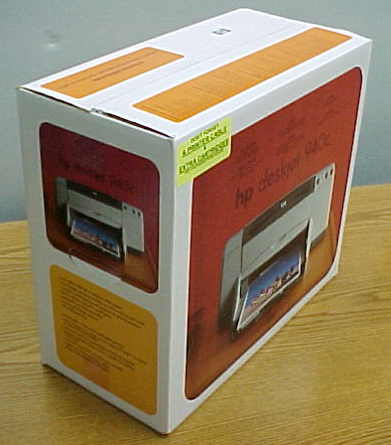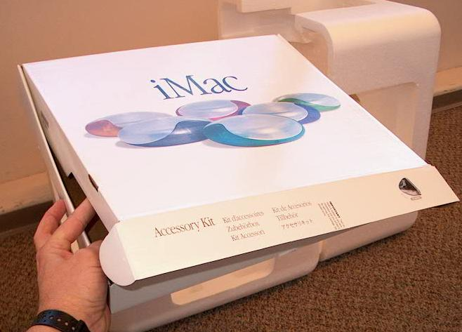
- Openings may be applied to the top or side of a container
- Flaps that meet in the center will NOT align perfectly so graphics on these flaps should not be dependent on them lining up.
- Most boxes fall into 4 major categories

Hand holes
- Carrying hand hole can be placed in several areas and are normally designed to address center of gravity, internal foam relief areas, and for heavier products – encourage two people handling. Designs should be flexible or recognize the need for hand holes. However, in many cases these hand holes retain the graphics and are not pushed into the box until the customer is carrying it to the cash register.

Symbols and labels
- Symbols – there are several kinds of symbols placed on a box. Regulatory and Partner trade marks
- Bar Codes (production in-house & UPC)
- Regulatory – marks required for sale in some countries (CE, greendot, etc.)
- Partner trademarks – symbols and trade marks that the company wants the customer to see (Microsoft XP, USB, EPA Energy Star, etc.)
- Labels – many companies places several labels on its packaging. These are required for internal processes, shipment, and product derivatives. Typically these are place on an “end panel.” In has been indicated that in Latin America the end panel is covered with labels.
- Localization – some companies has been successful in using specification and software version information on labels printed on demand at the factories. This information normally changes twice in the life of a product and having this information on labels helps reduce inventory scrap, printing plate changes, and increase the ability to do specials (additional components added for certain customer promotions)

Retail Box Pre-printing Considerations
- More plate changes for the Multi Version Languages. Reduce the versions to 2 colors Black and 1 PMS.
- Reverse type out of 4 color process will not look great within the printing processes of Preprint and postprint (exact tolerances vary between printing processes) this is due to register in the Mounting, press and paper. Key lines help hide this common registration issue.
- Large tint areas will have variation in color.
- Text Readability across the image can be an issue in dark images
- Registration issues multiple at each step in the process (making the plate, mounting the plate, and printing the material)
- Other graphic improvements:.
    - Removing model # copy and text from the process pictures plates.
      - Product pictures look cleaner
      - Allows model/SKU change with just the black text plate (this eliminates the need to buy a complete set of printing dies for a simple change)
    - It is a struggled to reverse out a logo and text in four-color process work. The workaround is to overprint in black but can not always print cleanly over the other process inks.
    - Picking lighter colors for the process builds. Flexographic preprint does a great job building line colors from a couple of the process colors, but when you get into darker shades (3 color) it's difficult to get a consistent smooth laydown of the color.

Violator Guideline Manufacturing

General Overview
- As discussed earlier on One-voice packaging graphics, the printing processes used and the size of the material being printed has a direct correlation to the alignment, registration, & color quality that can be held. The larger the material being printed, the more difficult it is to maintain these elements. Conversely, the smaller the material being printed the easier it becomes to get the right combination of factors. An example of this would be it is harder to hold plate registration and color consistency of an 80 inch wide material (Preprint) than on a 2 inch wide material (label stock). This is due to the tolerance related to the processes involved in the manufacturing processes.
- Violators are most likely produced in two ways; printed directly on the box material (3 processes – flexo post-print, flexo pre-print, & litho) or printed on an adhesive label. Each has elements that need to be addressed given the current direction.

Recommendations
- Have violator use existing spot color or build out of process colors.
- Avoid colors that use 3 or more process build colors (example: blues & purples)
- Select colors where traps and bleeds will not cause conflicts (example: yellow text in blue field will have a green halo effect around text from required trapping)
- No reverse text (white) out of process screen tint build colors. Best to use black text or one process build color that leverages base color (example: yellow background with green or red text on top).
- Avoid thin white outlines around color areas. They are hard to hold in registration and will be filled in if a register varies.
- Gradient and radiant are Ok in label printing and pre-print if only one or two process colors are involved. Best with overprint Black text of line color text.
- Avoid drop shadows (specifically over images). If used - vector drop shadow are easier to produce for printed boxes (20% shadow). Do not use drop shadows on labels (perimeter drop shadows look funny when label is die cut).
- Standardize on size and shape of violators. Develop a small, medium and large size for each shape and publish in the design guidelines. Have one set for printed box material and one for label stock. This will reduce tooling costs and lead times. Make the label version 1/8 inch larger around the whole perimeter (1/4 inch total). This will allow the label to be placed over a printed violator.
- Not addressed but should be called out in the guidelines – Location/placement of violator. Please 3/8 of an inch from all scores or design edge rollover over 3/8 of an inch on the other side. However, keep all text areas 3/8 of an inch from all scores. Reason; in the past violator have been designed for printed boxes have terminated at the edge of the box. This causes the violator and text to roll over the edge.

Specifics
Violation Colors
- Box material printing (all processes)
  - Have violator use existing spot color or build out of process colors.
    - Adding an additional spot colors adds cost and limits production locations
    - Process build colors may not reproduce desired color
  - Purples and blues hardest to reproduce in process work due to 3 process colors
- Label printing
  - Not a big issues - as these are normally smaller in size and printed independently from the boxes, it can have greater flexibility in spot color usage & selection and process build work can better match intended color.

Color Combinations
- Box material printing
  - Litho on small boxes (camera and ink cartridges) not a big issue as registration can be more tightly held.
  - Flexo post and pre-print
    - Select colors where traps and bleeds will not cause conflicts (example: yellow text in blue field will have a green halo effect around text)
    - No reverse text (white) out of process build colors. Best to use black text or one process build color that leverages base color (example: yellow background with green (solid Cyan overprinting yellow creates green text or solid magenta overprinting yellow to create the red text).
- Label printing
  - Not a big issue as registration can be more tightly held.
  - Greater flexibility in spot color usage so reversed out text less of an issue (no process build registration issues).

Additional Elements

- Box material printing
- General – thin white lines are hard to hold in registration and will be filled in if a register varies.

  - Litho on small boxes (camera and ink cartridges) not a big issue as registration can be more tightly held.
  - Flexo pre-print not a big issue if kept to one or two process colors
  - Flexo post print – no good – stick to solid line colors

- Label
  - Not a big issues - as these are normally smaller in size and printed independently from the boxes, it can have greater flexibility in spot color usage & selection and process build work can better match intended color.

Drop Shadows
- Box printing
  - Litho on small boxes (camera and ink cartridges) not a big issue as registration can be more tightly held.
  - Flexo post-print
    - Do not use drop shadows
  - Pre-print
    - Avoid drop shadows (specifically over images).
    - If used - vector drop shadow are easier to produce for printed boxes (20% shadow). Avoid Photoshop drop-shadows.
    - You will see a bolder line at the bottom and right edge of shadow to deal with trap and registration issues.
- Label
  - Do not use drop shadows on labels (perimeter drop shadows look funny on labels).

Shape
- No issues
- Standardize on size and shape of violators. Develop a small, medium and large size for each shape. Have one set for printed box material and one for label stock. This will reduce tooling costs and lead times. Make the label version 1/8 inch larger around the whole perimeter (1/4 inch total). This will allow the label to be placed over a printed violator. See examples below:
  - Box printing
    - Round: small – 2 inches, medium – 3 inches, larger – 4 inches
  - Labeling printing
    - Round: small – 2 ¼ inches, medium – 3 ¼ inches, larger – 4 ¼ inches

Examples

Position
Not addressed but should be called out in the guidelines – Location/placement of violator. Please 3/8 of an inch from all scores or design edge rollover over 3/8 of an inch on the other side. However, keep all text areas 3/8 of an inch from all scores. Reason; in the past violator have been designed for printed boxes have terminated at the edge of the box. This causes the violator and text to roll over the edge.
With solid overprinting background color
Will have a harder edge than designer wants in Flexo printing

