ECT from a User’s Perspective

Scott Longtin, CPP
Packaging Engineer
Industry Standard Servers
Hewlett-Packard Company
February 2003

Foreword
The study of the corrugated industry’s specifying of corrugated paperboard along with this paper was first presented at the Dimensions.02 conference. In February 2003, the paper was edited and updated (including references to the Compaq / Hewlett-Packard merger) and published through IoPP.

Abstract
This paper is the result of a study and its findings on how best to specify boxes and other corrugated packaging components for a global company to assure consistent quality and predictable physical properties. These objectives have been pursued at the same time the industry is driving to have corrugated specified only as ECT grade. At first glance, specifying ECT seemed to be the easy answer to meeting these requirements. However, while pursuing the adoption of ECT into the procedures, some confusion and a number of issues surfaced as a result of my research. I found that ECT grade board did not perform well in the express delivery environment and found that other users with diverse shipping environments had similar shortcomings with this grade of corrugated. Since our distribution model was shifting from a channel distribution model to a more direct shipment model, our specification of corrugated needed to comprehend stacking strength for transport and warehousing, along with puncture and tear resistance for our express delivery shipping environment.
Hewlett-Packard’s ISS (Industry Standard Servers) past method for specifying corrugated:
Correctly specifying corrugated to assure consistency from one location to another has been of high importance to HP ISS (division carried forward from pre-merger Compaq). Although corporately specified, HP ISS corrugated cartons are produced in numerous countries with different standards and manufacturing capabilities. For a number of years, our specifications called out a minimum burst value OR an equivalent ECT value. The mistaken use of equivalent burst and ECT values will be covered later. A box compression value was later added to the specifications in an attempt to assure stacking strength. Use of these three values confused suppliers as to which value should actually be used to manufacture the box. In most cases, the manufacturer would pick whichever value was most convenient. Box compression was rarely chosen since most sheet houses did not want to go through the trouble of performing this test. In some cases, suppliers attempted to meet all three requirements. Non-domestic box manufacturers used their own conversion charts to translate the specified values into metric values and provided board accordingly. As a result, board grades varied from location to location. The resulting inconsistencies made for a strong case to revise our method of specifying corrugated to assure consistency, regardless of manufacturing location, and clarify the performance requirements of our boxes.

The promise of ECT to be the new standard in specifying corrugated:
Exclusively specifying the use of ECT grade board seemed a logical solution to our problems. It appeared that all of our inconsistencies could be cleared up with a single standard that was measurable and directly tied to box compression. Besides this, there was the notion that ECT board was less expensive than the comparable burst grade boards, and readily available. With these perceived benefits in mind, I set out to develop a method for specifying board based on established stacking requirements.

One of the main objectives was to have the carton marked with the same value that could also be used to calculate box compression strength. If this marking was to be a Box Maker’s Certificate (BMC), the standard burst or ECT board grades, offered in Item 222 and Rule 41, needed to be used. I found that box manufactures were unwilling to apply a BMC with an ECT value other than those offered under the regulations. Therefore, I resolved to use the available ECT values to calculate box compression through the McKee formula, along with our established safety factor, to assure our stack strength requirements were being met. It was felt that since these ECT values were minimum ratings set up by the industry, this would assure box performance, and at the same time, allow box manufacturers the flexibility to use the various liners available to them that could equate into cost savings.

Clarification of Box Compression vs. Stacking Strength
The distinction between box compression and stacking strength is spelled out in the Fibre Box Handbook (1999), but is being restated here to minimize confusion. Box Compression Strength is a function of box perimeter, average ECT and bend resistance of the combined board along with box aspect ration (L x W) and other factors. Box compression can be determined either through testing to ASTM 642 or estimated through the Mckee formula. On the other hand, Box Stacking Strength is the maximum compressive load that a container can bear over a given length of time under given environmental conditions. This is usually estimated by multiplying the compression strength by a safety factor that represents the environmental conditions the box will encounter.

Liner combination assigned to both ECT and Mullen grades
I found that putting this new method of specifying ECT into practice raised numerous questions about the actual board construction that we were getting under this system. I found that each supplier had their own listing of liner combinations with their associated ECT and burst ratings. It was understood that these ratings could be used on the Box Makers Certificate (BMC) for boxes made from that board under Item 222 and Rule 41. Table 1 is an example of one corrugator’s listing showing the cross reference of ECT and Mullen burst ratings that are assigned to various board combinations.

Portion of a Supplier’s Burst and ECT Cross Reference
SINGLEWALL BOARD GRADE | MINIMUM MULLEN | MINIMUM ECT
33/26/33 | 150# | 26 | Typical Board Combinations and Minimum ECTs
33/33/33 | 150# | 26
33/36/33 | 150# | 26 | 23 ECT | 26 ECT | 29 ECT | 32 ECT | 40 ECT | 44 ECT | 55 ECT
35HP/26/33 | 150# | 29 | 26/26/26 | 33/33/33 | 33/33/42 | 42/26/42 | 42/26/69 | 69/26/69 | 90/33/90
35HP/33/33 | 150# | 29 | 23HP/26/23HP | 29HP/26/29HP | 29HP/33/38HP | 38HP/26/38HP | 38HP/26/62HP | 62HP/26/62HP | 76HP/33/76HP
35HP/36/33 | 150# | 29 |  |  |  | 35HP/26/35HP | 35HP/26/62HP | 58HP/26/58HP | 74HP/33/74HP
35HP/26/35HP | 150# | 32 |  |  |  |  | 38HP/26/58HP | 56HP/26/56HP
35HP/33/35HP | 150# | 32 |  |  |  |  | 35HP/26/58HP
35HP/36/35HP | 150# | 32 |  |  |  |  | 38HP/26/56HP
42/26/33 | 175# | 29 |  |  |  |  | 35HP/26/56HP
42/33/33 | 175# | 29
42/36/33 | 175# | 29 | The mediums are interchangeable. The minimum ECT will stay the same regardless of whether it is a 26, 33, 36 or 40 medium
42/26/35HP | 175# | 32
42/33/35HP | 175# | 32
42/36/35HP | 175# | 32
42/26/42 | 200# | 32
42/33/42 | 200# | 32
42/36/42 | 200# | 32
56HP/26/33 | 200# | 32
56HP/33/33 | 200# | 32
56HP/36/33 | 200# | 32
56HP/26/35HP | 200# | 40
56HP/33/35HP | 200# | 40
56HP/36/35HP | 200# | 40
56HP/26/42 | 200# | 40
56HP/33/42 | 200# | 40
56HP/36/42 | 200# | 40

Table 1

This table indicates that the different liner combinations can each be assigned equivalent ECT and burst ratings. However, there is significant overlap of these two ratings on both the high and low end. According to this listing, a 32 ECT rated board could have a burst rating anywhere from 150 pounds up to 200 pounds. On the other hand, a 200-pound burst rated board could have an ECT rating anywhere from 32 up to 40. This overlap seems confusing considering the equivalent burst and ECT values set up in Item 222/Rule 41. In the rules, both 32 ECT and 200-pound burst rated boxes are rated for the same maximum size and weight.

As I continued in my discovery process, I found that numerous papers had been published regarding these inconsistencies under the rules. Chad Thompsons’ paper titled “Box Strength Guidelines for Small Parcel Shipments”, presented at Dimensions.01 touched on this lack of correlation between the two grades. Alfred McKinlay addresses the confusion surrounding the use of ECT in the paper he wrote in 1992 titled “Corrugated Boxes: Commodity or Performance Specified?” He further addresses this issue in the paper he published during Dimensions.01 conference titled “Learning From The Past 100 Years”. Al’s papers suggest that many users have been, and continue to be, lulled into the belief that the Mullen burst grades have equal and corresponding ECT grades. Considering this information, along with the above table, it was clear that specifying a minimum ECT rating could not assure a consistent burst grade of board.

Confusion surrounding ECT Values
To compound the confusion, the minimum ECT rating, which is stamped with the BMC to comply with Item 222 and Rule 41, is different than the average ECT value that can be used to estimate box compression. I believe that a number of users have adopted the use of the minimum rating for calculating stacking strength to assure their requirements are being met. However, the average ECT values for many of the liner combinations will often far exceed the minimum ECT rating. This results in a very conservative estimate of box compression. Contrary to this, using a board’s average ECT to calculate box compression, with its known standard deviation, along with proper quality controls, can clearly benefit users with optimized box price/performance.

At this point in the discovery, the following questions surfaced:
- What were the average ECT and burst values of the various liner combinations?
- Was I correct to use the minimum ECT ratings for compression calculations, or should the average ECT values be used?
- How was the average user expected to comprehend these ratings and values?
- What really was the difference between the high performance liners and the basis weight liners? Surely, the ECT grade boards produced from high performance liners must have corresponding burst values.
- Could both burst and ECT be specified and have a BMC printed on the box for each?

These questions initially troubled a number of the representatives I talked to in the corrugated industry. The basic response was that board made from basis weight liners could not be stamped with an ECT BMC, and board made from high performance liners could not be stamped with a Mullen BMC. This seemed to conflict with what we saw in table 1. The probing of these questions lasted for quite some time before there was a reasonable understanding of all the issues.

Differences in paper used to make ECT and burst grade corrugated
To answer the most basic question regarding the difference between high performance paper and burst grade paper, Inland Paperboard and Packaging, Inc. was gracious to assist and provide a tour of their paper mill in Orange Texas on October 1, 2001. This tour answered a good number of questions regarding the differences in manufacturing the two grades of paper.

Differences in performance criteria:
Basis weight paper is produced to contain a specified amount of fiber per area of paper. The correct amount of fibers must be used in the paper making process in order to achieve the correct basis weight, which is expressed in pounds per 1000 square feet of paper. This in turn is needed to achieve the desired Mullen burst rating of the combined board. ECT board is produced using paper that is manufactured to a ring crush specification. Ring crush is measured in pounds-force per 6-inches of paper in the cross machine (web) direction. The test for this is performed using a sample 6” x ½” strip of paper that is placed into a fixture to form it into a ring shape. A compression test is then performed on the sample ring of paper (TAPPI T 818). The ring crush values of the liners that make up the combined corrugated board are used to predict its ECT value. The basis weight of this paper is not critical since the only defining characteristic is its ring crush value.

Since the two different paper grades used to produce their respective board grades are produced to their own specifications, there is little correlation between a combined board’s ECT strength and its burst strength. Because of these differences, the actual burst values of ECT rated board will vary greatly and the ECT values of Mullen grade board (burst) will also vary greatly.

Differences in the manufacture of the two grades:
Basic paper making principals and equipment are the same regardless of mill location. Both types of paper can be made with the same raw material on the same equipment. To do this, process and machine adjustments are made to differentiate the two grades. The fibers used for ring crush paper are refined to a higher degree than those used of basis weight paper. These fibers are ‘frizzed’ in much the same way we tend to get split ends in our hair. These frizzed parts of the fiber allow the fibers to better interlock with one another when the fibers are laid out on the Fourdrinier Table. These frizzed parts of the fiber also have an opportunity to align themselves in the cross machine orientation of the produced paper. Secondly, the Wire mesh on the Fourdrinier Table is slowed to almost match the velocity of the stock being put out from the head boxes. This helps the fibers maintain their random orientation on the wire mesh thus permitting more fibers to align in the cross machine direction. In contrast to this, basis weight paper is ‘pulled’ onto the Fourdrinier table with the wire mesh traveling at a much higher velocity than the fibers causing them to align in the machine direction (perpendicular to a container’s top to bottom compression). Lastly, ring crush grade paper receives additional calendaring and finishing.

Quality Assurance Testing of Both grades of Paper:
At the time of my visit to Inland’s mill, they were running their L70 high performance paper. Even though this paper is run to ring crush specifications, the QA department was performing burst tests on this paper. This test, along with testing for caliper, moisture content, and other attributes of the sample, were being performed with a machine that accepted a 12” wide sample section of the paper web. Ring crush tests, basis weight and Cobb tests were being conducted manually. All of the values derived from their testing were recorded and compared to a set of company specifications and used to make adjustments to the manufacturing process.

ECT Grade Boards Are Not Suitable For The Small Parcel Shipping Environment
During the time of my investigation, we had already started specifying ECT for our shipping boxes. It did not take long to realize that ECT board did not address the elements of our express delivery environment. Figure 1 shows a box that was specified with 51 ECT double-wall corrugated that encountered just two legs of express delivery. The ECT requirement was based on a 95 lb. Package weight, 4-unit stack height with a 5.12 Safety Factor.

51 ECT Grade Box After Two Express Delivery Shipments
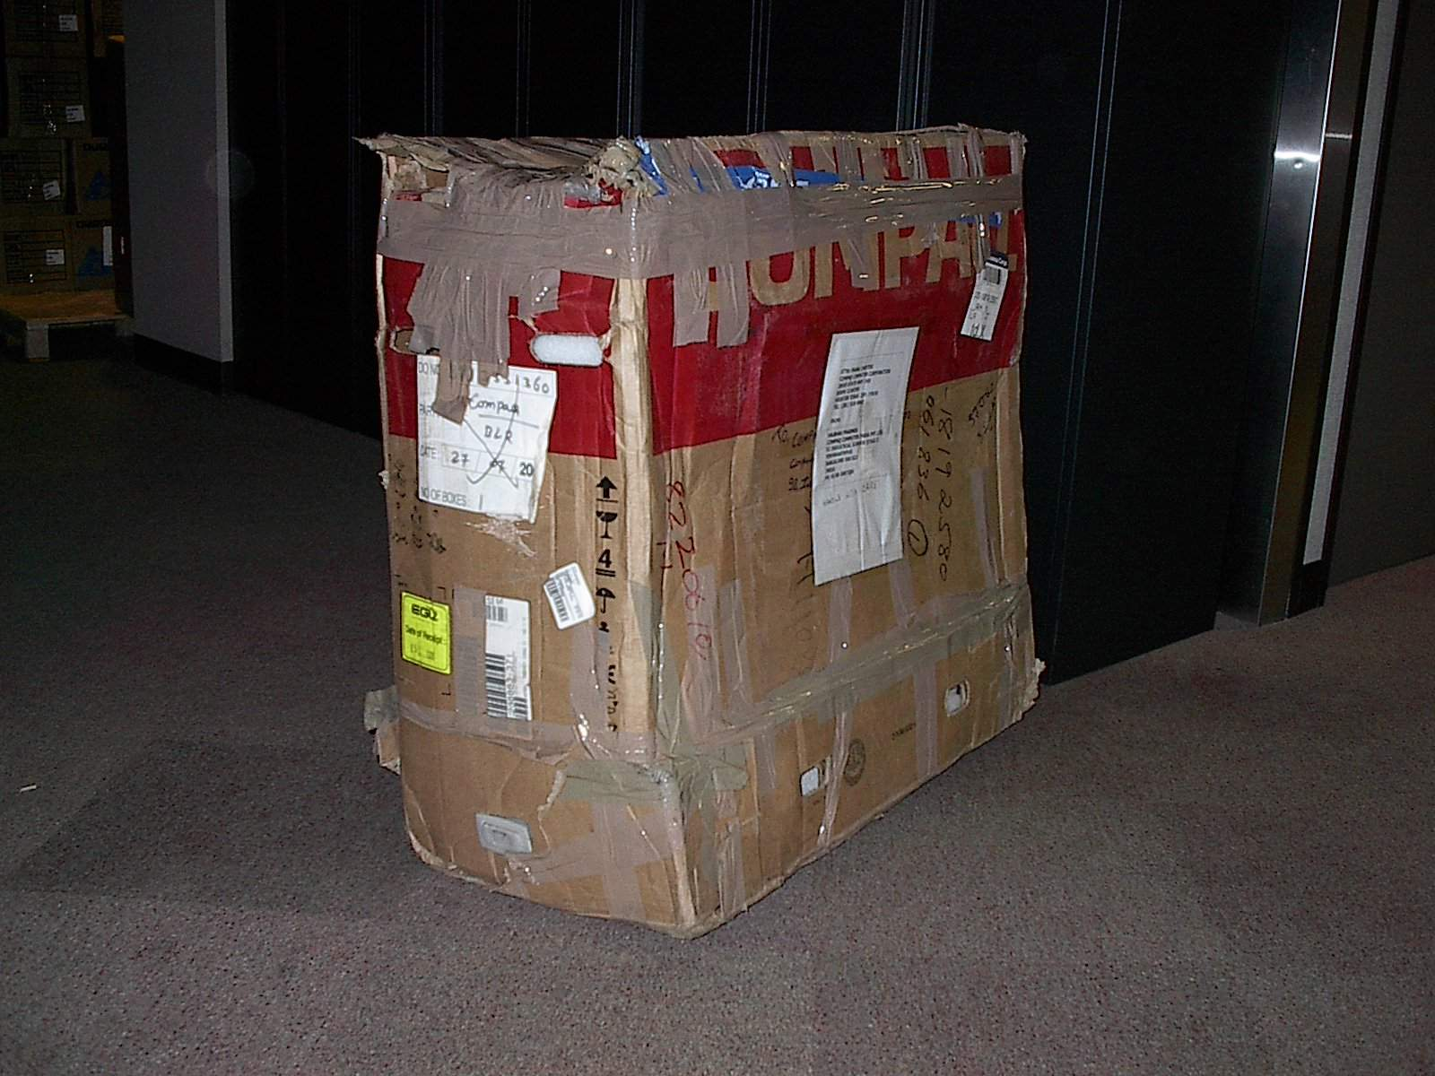
Figure 1

It was concluded from cases like this, that specifying board for stacking strength alone was not enough to address our entire distribution environment. Although we had identified stacking strength as an important attribute to address warehousing in the past, our distribution model had since shifted to include an increasing requirement for direct shipments of products through the small parcel express environment.

Specifying Boxes For The Small Parcel and Express Shipping Environments
Although the subject of packaging requirements to address the small-parcel shipping environment has been the topic of discussions for some time, recent studies, along with some published guidelines have provided users with some useful tools. ASTM D 5639/D5639M, Standard Practice for Selection of Corrugated Fiberboard Materials and Box Construction Based on Performance Requirements, provides considerable guidance on board selection in the Appendix section. This standard differentiates methods for board selection based on the intended distribution environment. Appendix X7.2 illustrates a method for determining box specifications for the small-parcel shipping environment. The Transport Packaging Committee of IoPP now has an initiative to address the requirements of packages subjected to the single-package shipping environment. Reviews of the committee’s document ‘Guide to Packaging for Small Parcel Shipments’ are in progress. Chad Thompson’s paper ‘Box Strength Guidelines for Small Parcel Shipments’ published for Dimensions.01 illustrates that weight limits and sizes spelled out in Item 222 and Rule 41 for the burst grade boards are over stated for this environment. Regardless of the rules and standards, performance testing should always be the determining factor for qualifying package requirements.

HP’s Need To Specify Both Burst and Compression
At this point in the investigation, the requirements for our shipping boxes was reviewed and reconsidered. With the information from my study thus far, it was determined that box ruggedness was the most important physical attribute for our boxes in order to withstand the hazards of the express delivery environment. It was clear that the tearing and puncture resistance properties of burst grade board were needed to meet this requirement. Although box compression was now identified as a secondary requirement, it still needed to be defined in order to address warehouse-stacking requirements in Europe and other locations. It was therefore resolved that both burst strength, along with either ECT or a box compression value, needed to be specified, and have both values marked on the boxes for QA purposes. This seemed to be an easy task with the use of tables (similar to table 1) that cross-referenced both attributes. However, putting this into practice was a rather hard sell.

Boxes Specified and Stamped With Both Burst and Box Compression Values
My request to suppliers to apply two BMC’s on a box was met with resistance and questions as to why this was needed. It was felt that this would somehow violate the carrier rules and could not be done. However, after numerous discussions on how both attributes could be specified and marked on the box, our corrugated suppliers have agreed to stamp a burst BMC along with a statement of box compression. Suppliers will be given the option to either calculate box compression through the McKee formula, or demonstrate it by testing production samples to ASTM D 642. Corrugated manufacturers are to maintain documentation and test results pertaining to this requirement. Inserts, trays and die cut boxes will be specified by burst grade alone, since these do not have any stacking requirements and depend heavily on tensile and tearing strength.

Implementation of New Specifications
The results of my study have driven the immediate implementation of specifying corrugated containers with both burst and box compression. Burst grade is chosen based on box size and weight and then qualified through performance testing. Box compression requirements are determined using a method similar to that described in Appendix X6 of ASTM D 5639/D5639M with our previously established safety factors. Hewlett-Packard’s ISS central corrugated specification has been overhauled as a result of this study. Box and corrugated drawing notes have been updated to drive suppliers to the new requirements. Additionally, metric equivalents have been included for burst and compression values to clarify our requirements for non-domestic board manufacturers.

Conclusion
It is clear that the lion’s share of consumer and commercial products, transported through known channels of distribution and clearly defined warehouse conditions, can clearly benefit from the use of ECT specified corrugated containers. However, the requirements identified in this paper, and the experiences of other organizations with similar requirements demand the need to specifying corrugated that address the small-parcel shipping environment. The significance of this distribution environment will continue to increase with the continued growth of e-commerce and direct-ship retailers and businesses.
References:
Annual Book of ASTM Standards, 2001, Volume 15.09

Fibre Box Handbook, 1992, 1999

Inland Paperboard and Packaging, Minden LA, Orange TX, working meetings and paper mill tour

International Paper, San Antonio TX, working meetings

Alfred McKinlay, 1992, “Corrugated Boxes: Commodity or Performance Specified?” IoPP Technical Journal

Alfred McKinlay, 2001, Dimensions.01, “Learning From The Past 100 Years”

Chad Thompson, 2001, Dimensions.01, “Box Strength Guidelines for Small Parcel Shipments”

Smurfit/Stone Container, telephone interview with Dave Carlson

Transport Packaging Committee of IoPP, “Guide to Packaging for Small Parcel Shipments”, 12/18/01 draft

Willamette Industries, Sealy TX, working meetings

