Managing Packaging as a Horizontal Process

A Paper Presented by:
Tim Lalley
Corporate Packaging Engineer
Hewlett-Packard
February 18th, 2002
Dimensions02

INTRODUCTION
How does one describe the value of packaging? Packaging helps to define a product, differentiate it from similar products, provides protection during shipping, and conveys important messages. According to Hine (1995) packages are an inescapable part of modern life yet are caught in a dichotomy: packaging is omnipresent and invisible, deplored and ignored. However, for most manufacturers packaging is the crucial final payoff to a marketing campaign. If packaging is so important to manufacturers how can this dichotomy exist? This describes the situation the Packaging discipline faces within most companies; packaging is an integral part of almost any product and manufacturing cycle but is often overlooked, misunderstood, or undervalued. This paper will outline why the packaging enterprise in Hewlett-Packard is using horizontal process management to compensate for this dichotomy and to redefine and promote the value that Packaging adds to the company.
BACKGROUND
It is important to understand one very important point: what I am talking about in this paper is driving major change in the packaging enterprise to yield efficiencies (drive out inefficiencies) and add additional value beyond traditional metrics. The world in which we operate has changed and therefore we, as packaging professionals, need to change. These change drivers are massive. They affect companies in ways that are just now becoming apparent. Just as the Internet has opened up new markets for manufacturers it has also resulted in increased competition. Basic supply and demand economic theory states that as competition increases (increased supply) a shift occurs driving prices down. As a result many companies are now looking for ways to reduce costs. For example, companies are now outsourcing their manufacturing to third parties to reduce overhead costs or shifting manufacturing to less expensive labor markets. For packaging it means an increased focus on cost effectiveness, in other words, reduce costs. For most engineers “reduce costs” means reengineering of the packaging itself. They look for cheaper materials, or redesign the packaging by making tradeoffs they would not normally consider, such as reducing shipping case strength. The need to add value, typically defined as cost reduction, may or may not drive the correct behaviors. Does a simple focus on cost savings give us the result we are looking for? Hewlett-Packard’s response to that question was no. Simple cost reductions are short-term. The value of reducing the amount, type, or quality of materials used, while adding value, does not drive longer-term value. There is only so much material that can be taken out of a packaging before adversely affecting the product itself in terms of increased damage through distribution or adverse customer perceptions. Hewlett-Packard’s response to the global economy was to re-invent itself to become a more process driven company. The packaging enterprise was selected to pilot this concept, determine its value and learn how to implement this major change initiative effectively.
For the purposes of this paper horizontal processes are defined as the sequences of end-to-end tasks that create customer value. Processes include all groups, individuals, and value-added/non-value added activities that are involved in Packaging from design to the customers’ doorstep. This would include the following:
- Design/Product Generation • Procurement
- Regional Packaging • Marcom/Graphics
- Suppliers • Manufacturing
- Logistics • CM/OEM/ODM
Viewing the end-to-end process paints a different picture than simply considering the function of packaging. End-to-end process management forces us to see things in a different light and focus on the total cost and total value of packaging and its interfaces. It forces us to gain an understanding of all the interconnections, process drivers, and determine what information is needed and when. In short, it forces us to see all activities involved in the process for what they are, either value added activities or non-value added activities. In contrast, focusing on the function of packaging forces us to look no further than the defined job scope of the Packaging Engineer. The function of packaging is much more narrowly defined than the end-to-end process of packaging.
WHY MANAGE PACKAGING AS A PROCESS?
To begin, I will outline some of the issues facing the packaging enterprise in Hewlett-Packard and perhaps many other companies as well. These issues can be summarized in the following way:

- Packaging is not a “Silo’d” function:
  - Packaging crosses all product and divisional boundaries.
  - Extends across the entire Supply Chain
  - Involves the total product life cycle.
- The packaging process cannot be rationalized
  - Processes differ from division to division
  - Processes are not defined or managed consistently
  - The objectives and goals are not clearly defined
  - The metrics of success are narrowly defined
- Packaging is the first thing a customer sees when interacting with a product.
  - Branding
  - Messaging
  - Why-to-Buy information
  - Product positioning
  - Customer interaction
1. The packaging function in is not a “silo’d” function. The packaging engineer is involved in the product life cycle from R&D through the end of life. Engineers have the unique responsibility of affecting product costs on a multiplier basis because this discipline crosses so many boundaries. For every $1 saved in packaging material costs a multiplier of 3 to 5 times (perhaps more) of overall system cost can be realized through logistics, storage (raw material and finished goods) and shelf placement costs.
- The packaging process cannot be rationalized. Packaging is a multi-disciplined function that crosses many boundaries in the company and has great breadth and depth. As a result it is difficult to define the end-to-end process and validate the value added by each step in the process. Rationalizing the end-to-end packaging process sheds light on the value added and non-value added activities and brings to surface the major opportunities for improvement. Once this is known management must set the proper metrics to drive behavior.
- Packaging is the first thing a customer sees when interacting with a product. Packaging provides a direct link to the customer and is the means by which customers differentiates and selects a product.
THE PROBLEM
As a result of the complex and multi-dimensional nature of Packaging it is important the communication flows and processes are well defined and the value-added activities validated. Communication flows related to packaging that are ad hoc, inefficient, hide problems, and cost the company time and money do not add value to the customer. For example, assume the following groups or organization were involved in the packaging development process: Packaging Engineering, Regional Packaging Representatives, Suppliers, Regional Contract Manufacturers, Marketing Communications (Marcom), and Procurement. Now, let’s consider the following example.
EXAMPLE 1:
Background – A company has manufacturing operation in Ireland, Germany, Mexico, and the United States. The headquarters, and all R&D/design functions, are located in the US.
The project – develop the packaging (protective foam and corrugated) for a new product that will be manufactured at all of the above locations.
The packaging engineer begins by designing and testing the package. When completed he/she emails the final packaging drawings to the groups that are involved in the process. The graphics department receives their copy of the specs and begins their work. Upon completion they email their graphics designs to the regional partners who review it only to find that corporate doesn’t know anything about how to market products in their regions. They proceed to make the necessary changes. Meanwhile the logistics department proceeds with working through the supply chain issues of how to transport the finished goods to market. The regional procurement people begin their work aligning the proper supply base and negotiating the appropriate contracts when their suppliers inform them that the designs are inefficient for their manufacturing equipment. The communication flow is becoming complex and based on information developed from corporate that doesn’t exactly match the regional capabilities.
Work is progressing when the packaging engineer discovers a small mistake in the design. Corrections are made and he/she resends the information to the original distribution list. The regional partners, charged with the responsibility to manufacture the product on time, have started their redesign and tooling purchases when they are informed of the change. Tools are scraped and emails are sent back to the corporate design teams informing them that additional changes need to be made in order for the designs to be more efficient in their regions. Costs are being incurred, schedules are in jeopardy, and people are unsure if the information they now have is correct. Sound familiar? This example can be illustrated by Figure 1.
Figure 1 describes the communication between these various groups as the product development process progresses. What emerges is a “spider web” of communication related to information the packaging engineer controls. The process is undefined, repetitive, inefficient and there is no clear owner; this situation costs the company time and money. In addition, these inherent inefficiencies can cause various other issues in the process such as late changes to the packaging.

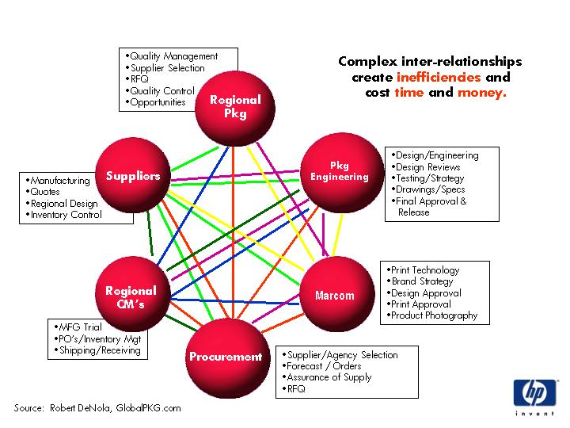

Figure 1

As previously stated, inefficient communication flows and processes can cause problems later in the development phase, this is illustrated by Figure 2. This describes the relationship of the cost of changes and impact to the schedule relative to time. The left vertical axis is labeled as the Cost of Change, the horizontal axis labeled as Time, and the right vertical axis is labeled as the Schedule Impact. The graph is positively sloped indicating that as Time progresses the Cost to make changes to a packaging design increases. For example, the cost to make a change before tooling has been completed is less than the cost to make a change after tooling has been completed. Likewise, as Time progresses the Cost of making changes (either in the form of structural changes or copy/graphics changes) has a larger Impact to the schedule compared to changes made earlier in the schedule. To use the previous example, changes made to tooling late in the development cycle may cause a delay in the planned product launch date. Conversely, a change made to tooling early in the cycle has a much smaller impact to the overall schedule. This is a very basic concept but one that many companies either choose to ignore or have inefficient resources to address.
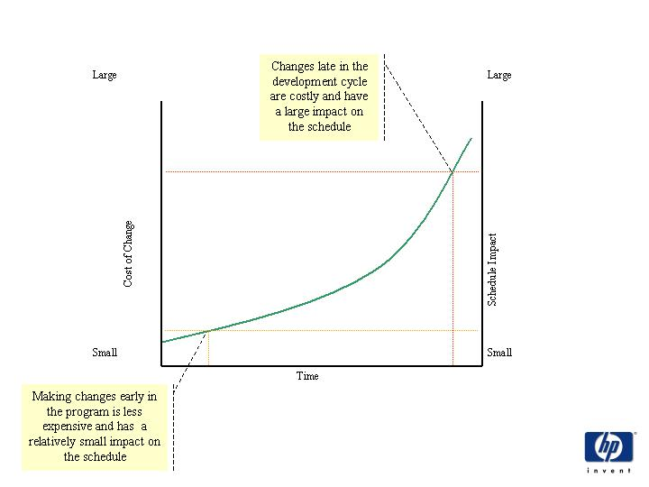
Figure 2

This example describes a Functional approach to packaging. In this approach the groups involved may claim they are efficient, in fact they may be, and that they do have a validated process that adds value. However from a an end-to-end process point of view it is inefficient, undefined, and shows how the actions of one group can cause adverse affects in other groups involved in the same commodity, in this case packaging. While each group, or silo, my be efficient and effective within their function the end-to-end process is not and the value of these activities to the customer is not clear.

A Value Added Focus
In this paper I have outlined how a functional approach to packaging may yield efficient processes within each silo but fails to address the end-to-end process efficiencies that create additional value. Now let’s discuss what is meant by additional value.
Engineers by nature tend to be technically focused. When engineers get a request by the company to describe their value, add additional value, or be cost efficient they tend to think in engineering terms. Essentially cost savings to an engineer means redesign, in this example, redesign the package. This next section describes how functional cost savings metrics applied to a packaging engineering group can yield material and logistical savings but can fall short of yielding longer-term system or process savings.
Figure 3 demonstrates the relationship between packaging costs and development time. The vertical axis is labeled as the total packaging cost while the horizontal axis is labeled as time. On the left side of the curve, early in the product development cycle, as cost savings projects or design revisions are undertaken a move is experienced from point 1 to point 2. This produces a relatively larger amount of dollar savings compared to the time it takes to achieve those savings ($/T). This is the so-called low hanging fruit that can make the packaging engineering department feel and look good. However it’s important to understand one very basic rule, there are only so many cost savings measures that can be undertaken before adverse effects, such as an increase in damage rate or negative customer impressions, are realized. This is depicted by the move from point 3 to point 4. Later in the development cycle cost savings efforts require more time and effort to achieve incrementally smaller amounts of savings. At this point in the product life-cycle it becomes increasingly difficult for the packaging engineer/engineering department to show continual value added activities. In this way it becomes clear that a continued long-term focus on cost savings is a dead end. All too often the packaging department is forced in to this situation as result of managements unfamiliarity with the value that the packaging department is capable of providing. Packaging engineers are the keepers of critical information for both products and materials. Remember, packaging is not a siloed function, it is in the unique position of being able to influence and impact change across the entire organization and through the entire supply chain. It is the duty of the packaging department to educate management in this overall value and change the metrics to drive the desired behaviors that result in total end-to-end improvements and value-added activities beyond cost savings.
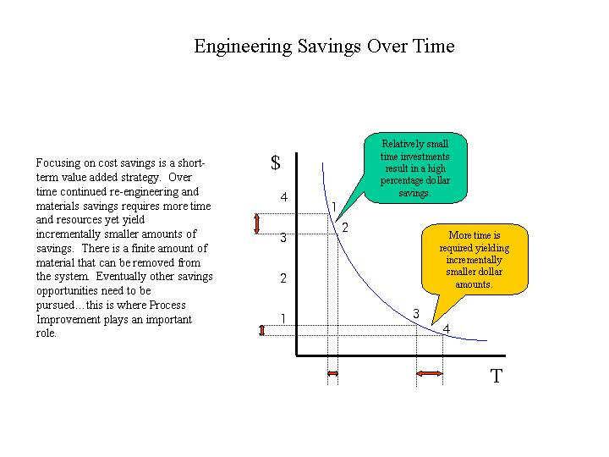
Figure 3

In summary the problems outlined in this paper include the following: un-validated and inefficient communication flows; how this causes problems in the process including changes late in the development cycle which result in high costs and large impact to the schedule; and how continued focus on costs savings initiatives as a value added activity provides short term value while ignoring the larger opportunity of HOW to do things BETTER. The next step is to discuss how process management helps to address these issues and helps the packaging enterprise become more value oriented and turn incremental savings into exponential savings.
WHY PROCESS MANAGEMENT
According to Michael Hammer – “In order to succeed, or even survive, it today’s global economy, companies must refocus and reorganize themselves around their processes: the end-to-end sequences of tasks the create customer value” (1996). Processes help to simplify functions, provide clarity for activities to be performed, and adds focus, purpose and direction to the organization. Processes are based on fact not fiction. They validate how and why things are done and ensure that only value-added or critical activities are in place. Processes allow for speed and accuracy of organizations reducing the need for re-work or late changes. They allow an organization to be nimble, agile and anticipate changes rather than react to them. All of this means that processes management provides opportunities for improvement within the company and helps to facilitate change when change is needed.
Focusing on the process of packaging, rather then the function of packaging means only value added activities are worked on, leaving more time for development and more time to monitor for changes that need to be made. An example of a process tool that helps address this issue is a centralized packaging specification/collaboration database and workflow system. Such a tool can greatly improve the validity and reliability of the process as well apply reason and logic to the flow of information. Further benefits could include:
- People getting the right information at the right time – a logical workflow means that all people involved in the process around the world will have on-time access to the information they need to perform their jobs effectively.
- Central databases allow access to the most current specifications – centrally stored information means the most up to date information can be accessed by anyone who needs it without having to make a phone call or send an email.
- Packaging information can be used to improve the business situation – accumulative packaging data can be used to improve procurement activities, identify cost reduction activities and other possible areas of improvement.

Consider Example 1 from above. In this example the company is developing a new product to be manufactured in Ireland, Germany, Mexico, and the United States while all design activities are centered in the United States. If end-to-end process management were applied to this example the following would be the result:
Change the systems and structures to provide everyone involved in the process with the correct tools and information to complete their task efficiently and accurately. All data is stored in a central location accessible via the internet. Rather than having several individuals responsible for a small piece of the process have one individual, a process manager, responsible for the end-to-end development of packaging. Such a person, by definition, would have the resources and therefore the visibility to better facilitate efficient and effective packaging development. In the previous example packaging was being designed, both structural and graphics, without full knowledge of the capabilities and requirements of each region where the products would be manufactured and distributed. The Process Manager is responsible for aligning all resources early in the development cycle to gather as much design input as possible from all regions. A central design and collaboration database helps to facilitate this activity. Designs are completed with more input and communicated via the specification system. When changed occur, late in the development cycle for example, the information is updated in one location and communicated to all regions. Regional suppliers, procurement and logistics people all have access to the most up-to-date information and can post required changes and updates to be accessed by the corporate designers. Time is saved, information is accurate, changes are dealt with quickly, costs are reduced, and the schedule is not in jeopardy. This is the value end-to-end horizontal process management can add to an organization.
Figure 4 shows that by organizing the packaging function around process management fundamentals the communication flow of critical packaging and product information is optimized resulting in:
• Shorter development times
• Reduced errors
• Packaging designs are optimized for manufacturability by the supply base.
• Packaging designs are optimized for manufacturability at the plant, CM, and OEM level.
• Reduced rework and redesign for Marcom and Packaging.
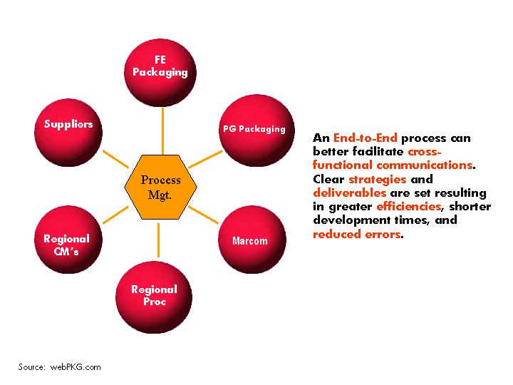
Figure 4
Managing packaging as a process provides clarity, purpose and organization to how packaging is developed taking into consideration all variables needed for overall end-to-end efficiency.
Process management allows for efficiencies in the above mentioned areas by creating the ability to align resources in more of a parallel fashion with all groups working from the same starting point and working towards common goals and deliverables. Figures 5 and 6 shows that by realizing the relationship between the various organizations related to the end-to-end packaging process, time savings can be achieved along with a reduction in the number of changes made late in the development cycle. By investing time to understand the total packaging process, and redesign it to yield greater efficiencies, the engineer can actually have more time for design and redesign.
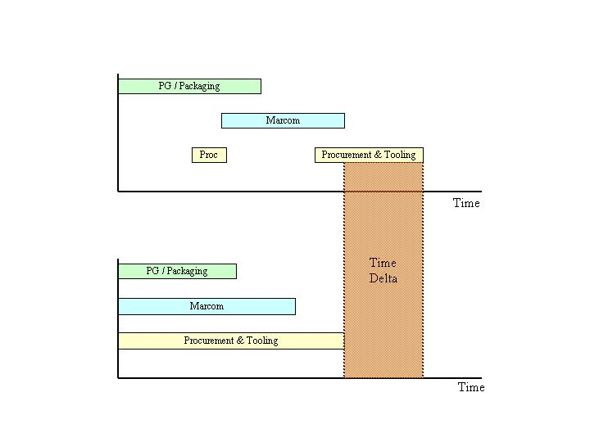
Figure 5
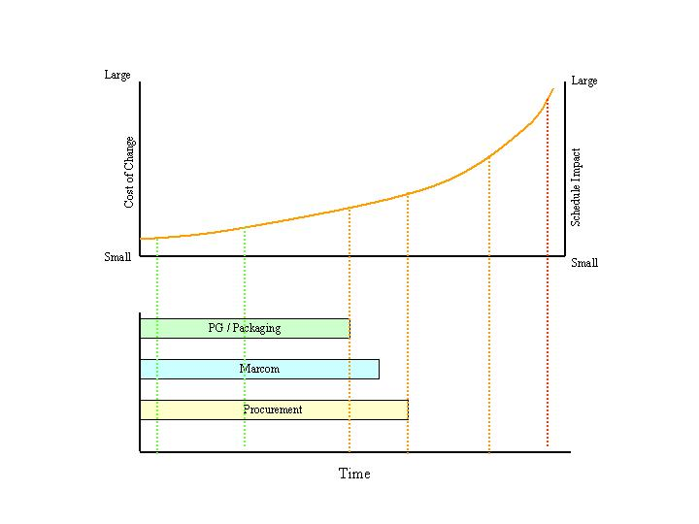
Figure 6
Let’s consider the typical design phases for packaging development. As shown in Figure 7 they are: product conception, prototype phase, design phase, manufacturing phase, and launch. The typical total phase may afford the engineer, for example, six opportunities for design revisions. By realigning resources and providing the business systems and structures needed for success (i.e. value-added activities only) the engineer may have more opportunities and time for design revisions. In addition, the time spent by the engineer on packaging design is time better spent due to a fuller understanding of the total process and taking into consideration more inputs at an earlier stage. If six design revisions yield a six times X quality design, then nine revisions yield a nine times X quality design, translating into up-front savings and an on-time launch.
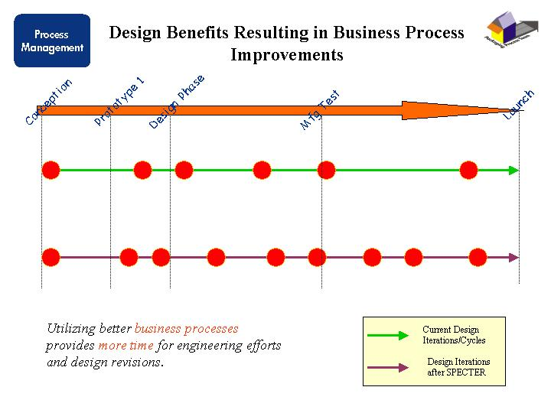
Figure 7
By managing packaging as a process rather than a function the Enterprise is able to focus on the total end-to-end value and add value beyond day-to-day functions and cost savings. Of course all of this means major change to the organization, involving many people in many different groups throughout the company. Change of this magnitude is not easily accepted and is difficult to implement. It is one thing to simply write about why to manage packaging as a process, it is another thing all together to demonstrate how to do it. In the next section we will take a look at why this is the case, how to manage major change initiatives, and most importantly why companies and organizations need to change.
MANAGING MAJOR CHANGE
If we take a look at the historical change drivers that effect businesses a partial list would include: new technologies, customer preferences, industry dynamics, competitor activity, commoditization of products, and possibly governmental policies and regulations (Hammer, 2001). The common thread of these typical change drivers is that they affect a few people in a big way and many people in a small way. These change drivers are focused on certain functions within an organization and have large implications but with a relatively narrow focus. But the world itself has changed; today companies face a different set of change drivers. Our world today is driven by technology and populated with well-informed consumers using this technology infrastructure to educate themselves and make purchases across geographical boundaries with the use of the Internet. Today, your nearest competitor is only a mouse click away.
If we take a look at some of the issues driving change in industry today they would include: Globalization of businesses and markets, the internet and e-business development, shared services, ERP implementations, merger integration, and supply integration (Hammer, 2001). These change drivers are different than the typical change drivers in that they affect many people in the company in a big way and a few people in a little way. This isn’t to say that the new, or emerging, change drivers are replacing the typical, or historical, change drivers. The fact is that the emerging change drivers are in addition to the typical change drivers. Saying that change is getting worse and it’s coming faster can summarize the result. This can be attributed to the great improvements in communications infrastructure, the accumulation of knowledge, technological advances (the internet for example) and perhaps one of the most unique reasons, companies have to be focused on customer preferences more now than ever. As Michael Hammer put it, change has changed. Change is bigger; it touches a very large number of people in a company. It is broader in that it affects many different aspects of the business. And change is deeper meaning that it has major impacts on what it affects within the company. Change involves many organizations, it’s global, everyone in the company is affected, and change is pervasive throughout the organization.
With that said, why are companies forced to embrace change? As Tom Peters stated in his 1994 book Seminar, “In order to keep up with global competition, manufacturers must have the ability to get products to market faster, with less resources and at a low cost while maintaining or improving quality”.
Michael Hammer describes this need the following way: If we were to take a look at the ratio of internal change over the rate of external change the outcome could have three possible results: greater than 1, equal to 1 or less than 1. If a company is not able to change internally as quickly as external (market or global) change then the company is not able to keep up and becomes a victim. If a company is able to change internally at the same rate as external change then the company is maintaining status quo; they are a survivor. If a company is able to adjust internally more quickly than external change then the company has the ability to gain market share and thus they are a winner in the market place. This is the ultimate capability that we, as packaging professionals, should strive for. Wayne Gretzski said it best, “Don’t skate to where the puck is, skate to where the puck s going to be”. It comes down to the ability to anticipate change and not react to it.
If we want to have the ability to be a winner, change internally faster than things change externally, then we need to have the processes in place to understand how things are changing externally and be able to implement these changes quickly. Historically businesses fail to understand this point and fail to have the courage to make the changes necessary to adapt to the changing market drivers. Most companies adapt to change by shuffling how and where people report, otherwise known as the “re-organization”. The typical reorganization is like shuffling the chairs on the Titanic, the change will not affect the outcome in any way. Managers need to have the ability to understand the situation and what the outcome will be if drastic action is not taken. I often use the definition of insanity to describe this situation; insanity is doing the same things the same way every time and expecting a different outcome. If the global economy is changing in a drastic manner then a simple shuffle of who reports to whom will not be effective. Organizations need to realize, and be willing, to make the difficult decisions of how to do business different, not just better.
However major change in any organization is scary. Change disrupts lives; it forces people into unfamiliar territory. Change is uncomfortable; it pushes people out of their comfort zones. And change has no constituency; change is pushed from the top and is not supported by the general employee population. This is perhaps the most important point because when change is pushed onto people they will resist. As Michael Hammer states, people don’t mind change as much as they mind being changed.
Now that we understand that people will resist, it is important to understand the various forms of resistance. So, how do people resist change? The most common forms of resistance are (Hammer, 2001):
- Dismissal, denial and rationalization: In this form of resistance employees ignore or dismiss the need for change. Employees rationalize why a change initiative will not work. “We tried this years ago and it didn’t work so why should it work now?”
- Argumentation: In this form of resistance employees argue that not enough information is known to make a decision regarding the proposed change.
- Passive aggression: characterized by an individual’s appearance to support the change initiative when he/she actually is not supportive and in fact may be working behind the scenes to prevent the change from happening.
- Active non-compliance and explicit obstructionism: A person exhibiting these forms of resistance will tell you they will not support or comply with the requested change and/or try to sabotage the initiative.

In order to implement process change in a packaging organization, or any organization for that matter, the project manager must gain the buy-off and support of the people involved in the process. The solutions are surprisingly simple:
- Make people part of the solution • Explain the situation
- Be supportive • Create project momentum
- Tell the truth • Deliver results
- Engage the community • Repeat project goals continuously
TOOLS FOR MANAGING CHANGE
In 1991 the Gulf War caused Jack Welch, CEO of General Electric, to say, “I can’t predict the future anymore”1, which lead to his recognition that GE’s ability to adapt to change was key to the future success of the company. They found that GE, like most companies, was historically good at managing the technical portion of change, the designing and developing portion, but they we not as good at managing the acceptance side of change. Furthermore, it was found that most major change initiatives under-perform due to poor acceptance of the people leading change and/or those affected by it; not because it was the wrong change or poorly designed. Further research indicated a fundamental pattern. First, change, even the “right change” or “good change”, with a strong technical plan had poor results or failure when combined with a low acceptance component. Secondly, changes with an average or low technical plan accompanied with high acceptance out perform change initiatives with a high quality technical plan accompanied with a low acceptance plan…every time. This fundamental understanding lead to the Change Acceleration Process (CAP).2
The Change Acceleration Process (CAP) is based on one simple equation: E = Q x A where:
- E represents the “effectiveness” of the result.
- Q is the “quality” (technical strategy) of the initiative.
- A is the “acceptance” (cultural strategy) of the initiative.
This equation represents the key to a successful change initiative. The premise is that the quality of the change initiative multiplied by the acceptance of the people leading the change or affected by it, will equal the effectiveness of the result. In other words, pay as much attention to the cultural strategy as you do to the technical strategy. The process is based on seven stages aimed at the development of an efficient and effective change strategy as shown in Figure 8. They are:
- Leading Change – Sponsorship for the change is clear. Leaders publicly and privately commit to making change happen by garnering resources necessary to sustain it and by giving personal time and attention needed to follow-through.
- Creating a Shared Need – The reason to change, whether driven by threat or opportunity, is widely shared though data, demonstration or diagnosis. The need for change must exceed its resistance.
- Shaping a Vision – The desired outcome of change is clear, legitimate, widely understood and shared.
- Mobilizing Commitment – There is a strong commitment from key stakeholders to engage in the change, make it work, and demand and receive management attention. Responsibilities are established and employees involved actively support progress through personal time, attention and learning.
- Making Change Last – Once change is started, it endures through implementation plans, follow-through and establishment of accountability. New learning are transferred throughout the organization.
- Monitoring Progress – Indicators are in place to monitor and measure progress; milestones are established and reached; benchmarks are set and realized.
- Changing Systems & Structures – staffing, development, measurements and rewards, effective communication, organization design, information systems, and resource allocation systems.
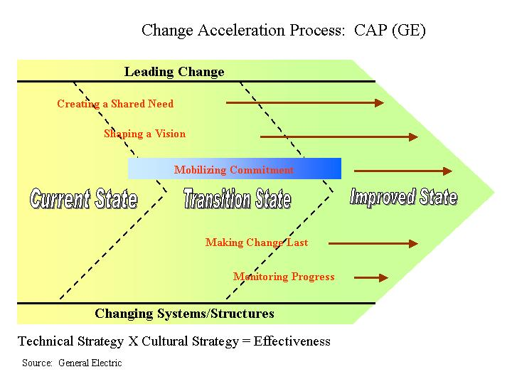

Figure 8
The CAP tool is an extremely effective process for managing and implementing major change initiatives. In short, it is a process for process change. As such, all steps of the process must be followed in order to ensure effective implementation. If any steps are skipped the process fails and the you run the risk of having an unsuccessful project.

SUMMARY
This paper has outlined what process management means, why HP is managing packaging as a process rather than a function, and why HP and other companies need to find better ways of managing their businesses. Process management is defined as the end-to-end sequences of tasks that create customer value. Processes help us focus on value-added tasks and redesign or eliminate non-value added tasks resulting in efficiency and agility. The Packaging Enterprise in Hewlett-Packard has re-invented itself to become a more process-focused organization to take advantage of these benefits. In order to better facilitate this organizational change the Change Acceleration Process is being used. This is a process for process change that has proven effective in many global companies by applying a technical and cultural strategy resulting in effectiveness. HP feels packaging is the best organization in which to pilot this new way of doing business because packaging is not a “silo’d” function, it crosses all product and divisional boundaries, extends across the entire supply chain, involves many different disciplines within the company, the process has not been rationalized, and packaging is a direct link to the customer.
The intent of this paper was to outline a high level view of process management and to demonstrate why packaging should be managed as a process. More work needs to be done in this area and I hope I have inspired people to pursue better and different ways of managing their packaging diciplines.
REFERENCES
The Tom Peters seminar. (1st ed.). (1994). New York, NY: Random House Inc.

Beyond reengineering: how the process-centered organization is changing our work and our lives / Michael Hammer. (1st ed.). (1996). New York, NY: HarperCollins Inc.

The total package. (1st. ed.). (1995). New York, NY: Little, Brown and Co.

1 Material available from the author
2 General Electric / CAP materials presented at Michael Hammer seminar: Marketing Change: Selling Change to Internal Constituencies, presented by Kimberly-Clark. October 2001. Material available from the author.

